Custom Project
Name: Joshua Eng Han Ruong
Student ID: 36340197
Date: 30 April 2026

Project Pitch

Initial Data / Class Model
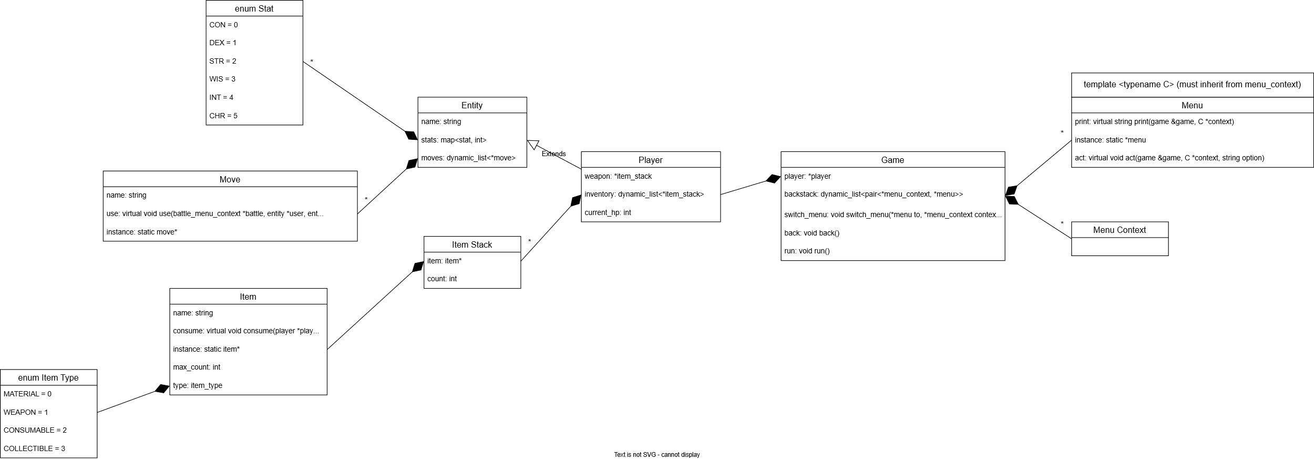

Using GenAI:
I do not plan on using generative AI.

Overview:
<What’s your project? Why does it excite you??>
My project is a terminal-based dungeon crawler game. The UI (insofar as it can be called that) structured as a series of text menus with a description and a list of options. Users type in option numbers to navigate between menus and progress the game. The game itself is structured as a series of rooms. Each room contains an encounter, which will usually be a battle, but may also be a puzzle or loot, among other things. Some rooms have branching pathways, but whether the player should be allowed to backtrack I have not yet decided, since it will involve creating an internal representation of a map. The combat is turn-based, with players having options to attack, cast spells, or use items. The contents of their inventory and weapon slots determine what exactly they can do. The inventory might be scrapped in favour of just a few weapon and equipment slots if it takes too long. The extra feature I will be using is class polymorphism and concepts. It’s exciting because it’s creating a game. What more do you need?

<How did you come up with your project pitch?>
The first thing is that I wanted to make it a terminal program. I didn’t want to spend time sourcing or creating graphics, and I know from experience that low-level graphics can be very tricky. I didn’t want to make a management-type program like most of the tasks in this unit are, since they tend to be limited in scope and may not be able to show the all the requisite skills. In the end, I decided to make a terminal game since it can be quite complex with room to add more, and it is also an idea I am interested in.

